DESCRIPTION.

**Using the given dataset find the following**.

1. **The number of movies released between 1950 and 1960.**
2. **The number of movies having rating more than 4.**
3. **The movies whose rating are between 3 and 4.**
4. **The number of movies with duration more than 2 hours (7200 second).**
5. **The list of years and number of movies released each year.**
6. **Total number of movies in dataset .**

**Initial steps before proceeding**

Create a database and use the database for use

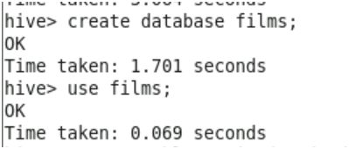

Create a table movies



Load movie data into movies table

**Answers**

**1.The number of movies released between 1950 and 1960**

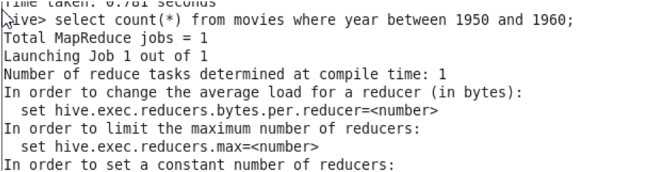

**2.The number of movies having rating more than 4**

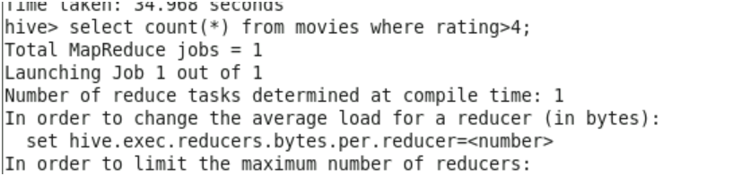

**3.The movies whose rating are between 3 and 4**

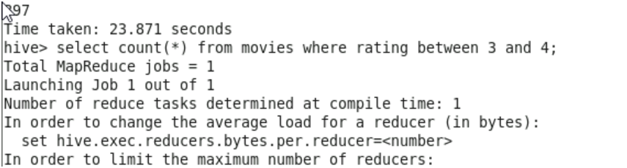

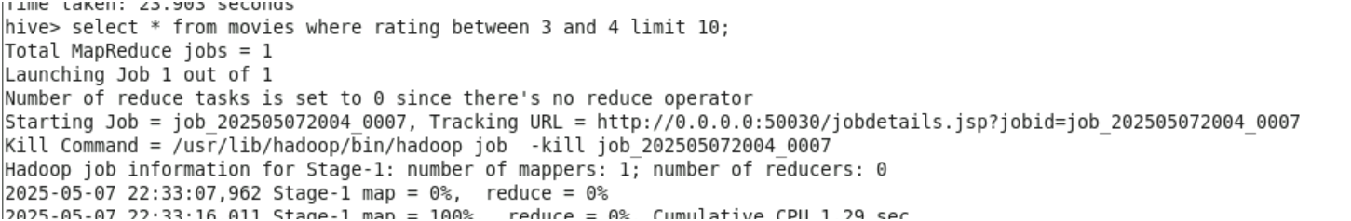

**4.The number of movies with duration more than 2 hours (7200 second).**

There is change in column name reviews ,it should be duration So changing the column name before proceeding.

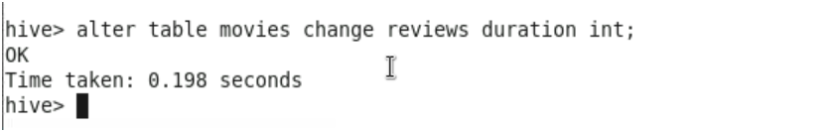

**5. The list of years and number of movies released each year**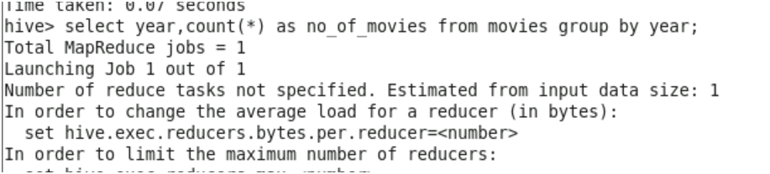

**6.Total number of movies in datasets**

